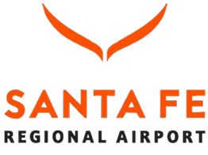

PUBLIC MEETING
Santa Fe Regional Airport
City of Santa Fe, New Mexico

The Santa Fe Regional Airport (SAF) will hold a public meeting to discuss the proposed new access road project that would connect the NM Highway 599 and Jaguar Road interchange to Aviation Drive just east of the new airport parking area. The project area includes a 500 to 800-foot-wide study corridor between the interchange and the parking area, as shown in the map below.
Meeting Date and Time: April 15, 2026, 5:00 PM to 7:00 PM
Meeting Location: Santa Fe Community Convention Center, 201 W Marcy Street, Santa Fe, NM
Coronado and DeVargas Meeting Rooms

The purpose of the meeting is to present the reasons the project is needed, alternatives currently under consideration in the study phase, and the project schedule, as well as to solicit public input on the project. Information will also be presented, and public comments solicited, on environmental issues, community/business concerns, and landscape/aesthetics treatments.
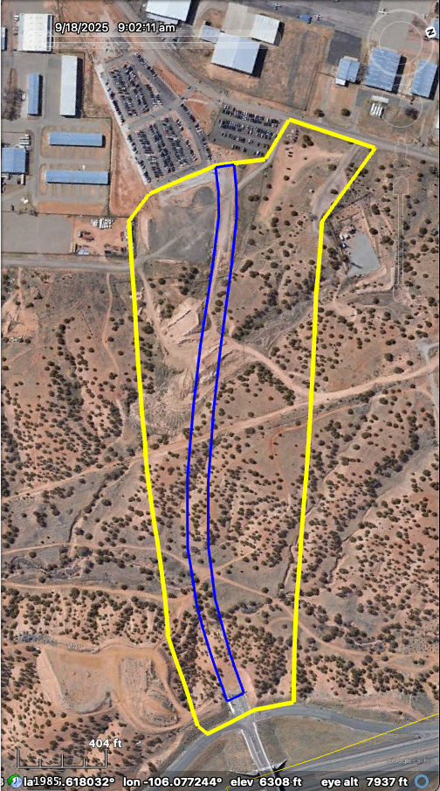
If you have questions and/or you are unable to attend the public meeting, please contact:

James Garduño, Project Manager,
Santa Fe Regional Airport,
at (505) 955-2906 / jdgarduno@santafenm.gov
or
Jonah Ruybalid, PE for Molzen-Corbin & Assoc., Inc., at (505) 242-5700 / jruybalid@molzencorbin.com

Project displays, information, and project representatives will be available to address questions. In addition, a presentation on the project will be given followed by additional public comment. Refreshments will be provided.
Public input for the proposed project will be accepted at any time; however, the Santa Fe Regional Airport asks that comments and/or questions specific to this meeting be sent no later than April 15, 2026.

You may also email your comments to Devin Kennemore at: devin@pathfinderenvironmental.com

To request Americans with Disabilities Act (ADA) related accommodations for this meeting, please contact James Garduño at least two days before the meeting at (505) 955-2906.

